interview questions:

**Q1. What do you know about DevOps?**

**A1.** Your answer must be simple and straightforward. Begin by explaining the growing importance of DevOps in the IT industry. Discuss how such an approach aims to synergize the efforts of the development and operations teams to accelerate the delivery of software products, with a minimal failure rate. Include how DevOps is a value-added practice, where development and operations engineers join hands throughout the product or service lifecycle, right from the design stage to the point of deployment.

Q2. **Why has DevOps gained prominence over the last few years?**

A2. Before talking about the growing popularity of DevOps, discuss the current industry scenario. Begin with some examples of how big players such as [Netflix and Facebook](https://techbeacon.com/10-companies-killing-it-devops)are investing in DevOps to automate and accelerate application deployment and how this has helped them grow their business. Using Facebook as an example, you would point to  Facebook’s continuous deployment and code ownership models and how these have helped it scale up but ensure quality of experience at the same time. Hundreds of lines of code are implemented without affecting the quality, stability, and security.

Your next use case should be Netflix. This streaming and on-demand video company,  follows similar practices with fully automated processes and systems. Mention the user base of these two organizations: Facebook has 2 billion users while Netflix streams online content to more than 100 millions users worldwide.  These are great examples of how DevOps can help organizations to ensure higher success rates for releases, reduce lead time between bug fixes, streamline and continuous delivery through automation, and an overall reduction in manpower costs.

A3. The more popular DevOps tools include:

        a. Selenium

        b. Puppet

        c. Chef

        d. Git

        e. Jenkins

        f. Ansible

        g. Docker

Thoroughly describe any tools that you are confident about, what it’s abilities are and why you prefer using it. For example, if you have expertise in Git, you would tell the interviewer that Git is a distributed Version Control System (VCS) tool that allows the user to track file changes and revert to specific changes when required. Discuss how Git’s distributed architecture gives it an added edge where developers make changes locally, and can have the entire project history on their local Git repositories, which can be later shared with other team members.

Now that you have mentioned VCS, be ready for the next obvious question.

Q4. What is version control and why should VCS be used?

A4. Define version control and talk about how this system records any changes made to one or more files and saves them in a centralized repository. VCS tools will help you recall previous versions and perform the following:

* Go through the changes made over a period of time and check what works versus what doesn’t.
* Revert specific files or specific projects back to an older version.
* Examine issues or errors that have occurred due to a particular change.

Using VCS gives developers the flexibility to simultaneously work on a particular file and all modifications can be logically combined later.

Q5. Is there a difference between Agile and DevOps? If yes, please explain.

A5. As a DevOps engineer, interview questions like this are quite expected. Start by describing the obvious overlap between DevOps and Agile. Although implementation of DevOps is always in sync with Agile methodologies, there is a clear difference between the two. The principles of Agile are associated to seamless production or development of a piece of software. On the other hand, DevOps deals with development, followed by deployment of the software, ensuring faster turnaround time, minimum errors, and reliability.

If you are preparing for senior DevOps roles, prepare for these specific Chef DevOps interview questions.

Q6. Why are configuration management processes and tools important?

A6. Talk about multiple software builds, releases, revisions, and versions for each software or testware that is being developed. Move on to explain the need for storing and maintaining data, keeping track of development builds and simplified troubleshooting. Don’t forget to mention the key CM tools that can be used to achieve these objectives. Talk about how tools like Puppet, Ansible, and Chef help in automating software deployment and configuration on several servers.

Q7. How is Chef used as a CM tool?

A7. Chef is considered to be one of the preferred industry-wide CM tools. [Facebook migrated its infrastructure](https://techbeacon.com/10-companies-killing-it-devops) and backend IT to the Chef platform, for example. Explain how Chef  helps you to avoid  delays by automating processes. The scripts are written in Ruby. It can integrate with cloud-based platforms and configure new systems. It provides many libraries for infrastructure development that can later be deployed within a software. Thanks to its centralized management system, one Chef server is enough to be used as the center for deploying various policies.

Q8. How would you explain the concept of “infrastructure as code” (IaC)?

A8. It is a good idea to talk about IaC as a concept, which is sometimes referred to as a programmable infrastructure, where infrastructure is perceived in the same way as any other code. Describe how the traditional approach to managing infrastructure is taking a back seat and how manual configurations, obsolete tools, and custom scripts are becoming less reliable. Next, accentuate the benefits of IaC and how changes to IT infrastructure can be implemented in a faster, safer and easier manner using IaC. Include the other benefits of  IaC like  applying regular unit testing and integration testing to infrastructure configurations, and maintaining up-to-date infrastructure documentation.

If you  have completed a [certification on Amazon Web Services (AWS)](https://www.simplilearn.com/cloud-computing/aws-devops-architect-certification-training), and are interviewing for niche roles such as AWS-certified DevOps engineer, here are some AWS DevOps interview questions that you must be prepared for:

Q9. What is the role of AWS in DevOps?

A9. When asked this question in an interview, get straight to the point by explaining that AWS is a cloud-based service provided by Amazon that ensures scalability through unlimited computing power and storage. AWS empowers IT enterprises to develop and deliver sophisticated products and deploy applications on the cloud. Some of its key services include Amazon CloudFront, Amazon SimpleDB, Amazon Relational Database Service, and Amazon Elastic Computer Cloud. Discuss the various cloud platforms and emphasize any big data projects that you have handled in the past using cloud infrastructure.

Q10. How is IaC implemented using AWS?

A10. Start by talking about the age-old mechanisms of writing commands onto script files and testing them in a separate environment before deployment and how this approach is being replaced by IaC. Similar to the codes written for other services, with the help of AWS, IaC allows developers to write, test, and maintain infrastructure entities in a descriptive manner, using formats such as JSON or YAML. This enables easier development and faster deployment of infrastructure changes.

As a [DevOps engineer](https://www.simplilearn.com/devops-engineer-masters-program-certification-training), an in-depth knowledge of processes, tools, and relevant technology are essential. You must also have a holistic understanding of the products, services, and systems in place. If your answers matched the answers we’ve provided above, you’re in great shape for future DevOps interviews. Good luck! If you’re looking for answers to specific DevOps interview questions that aren’t addressed here, ask them in the comments below. Our DevOps experts will help you craft the perfect answer.

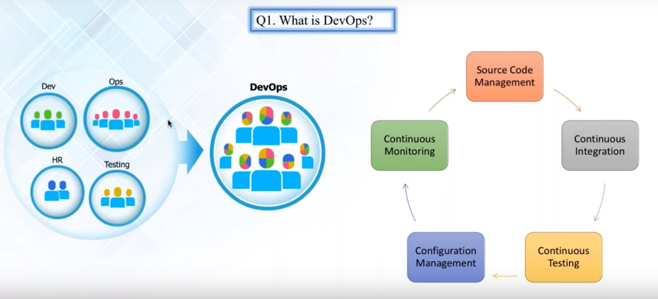

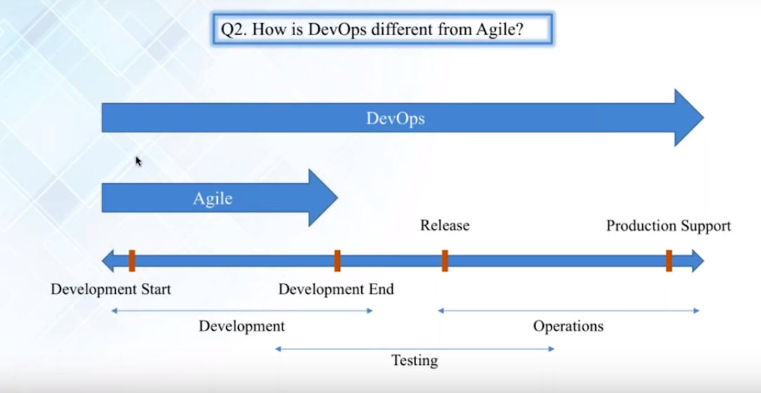

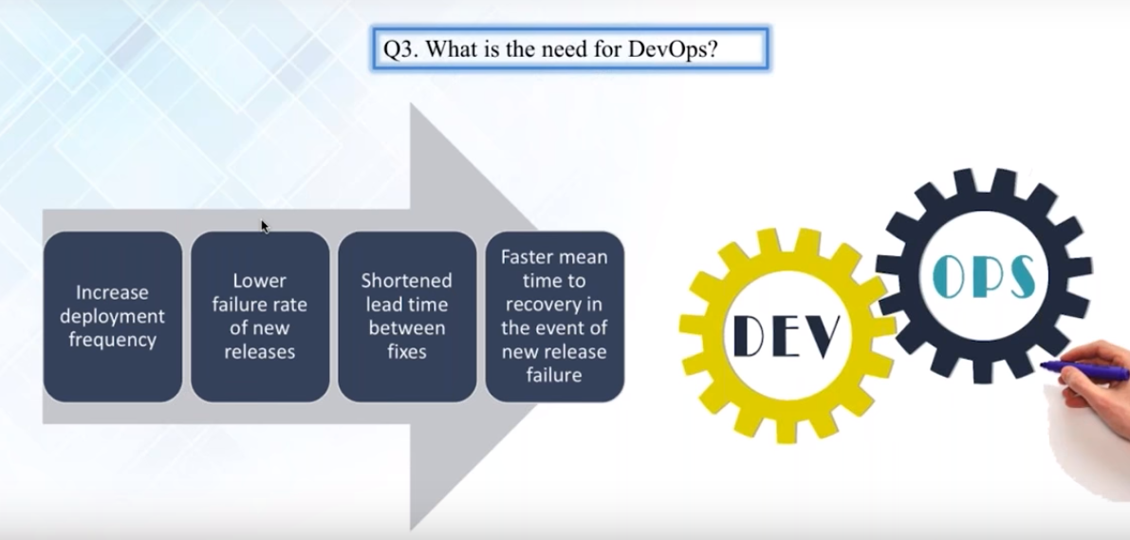

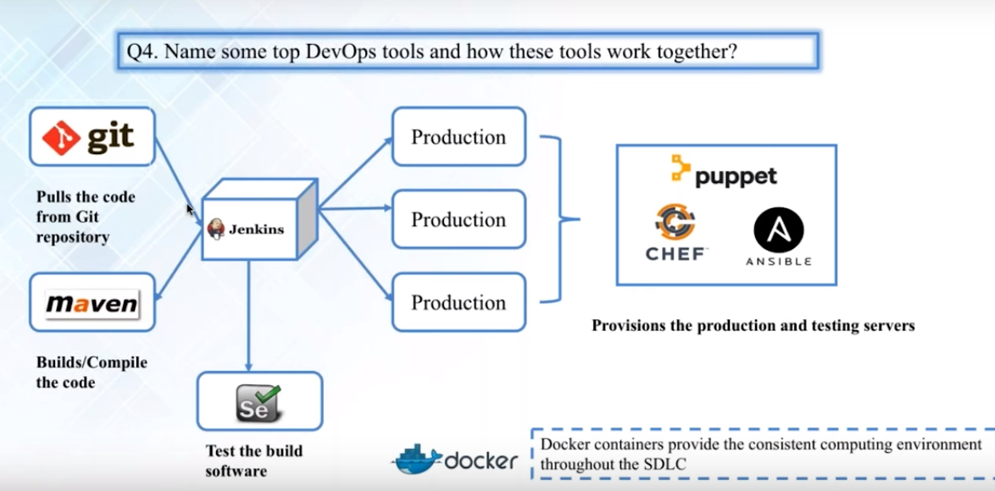

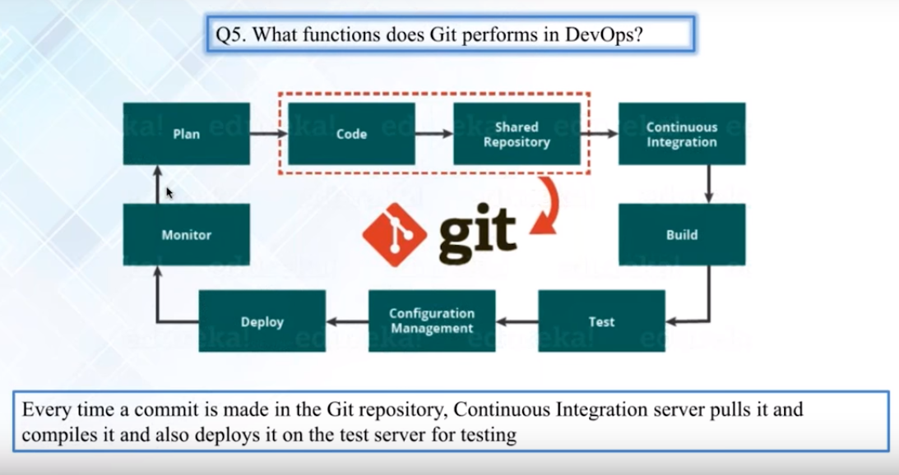

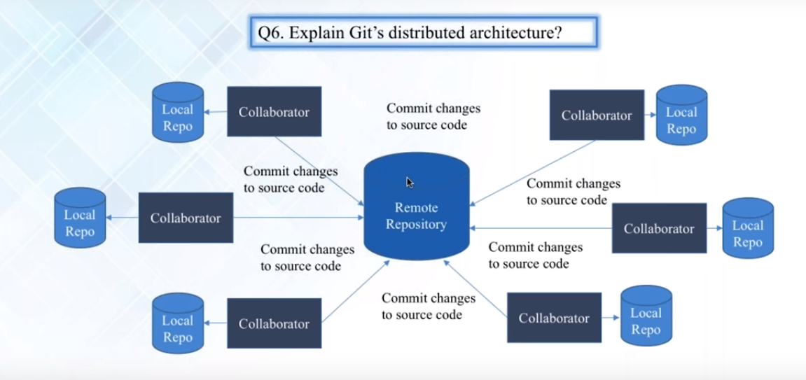

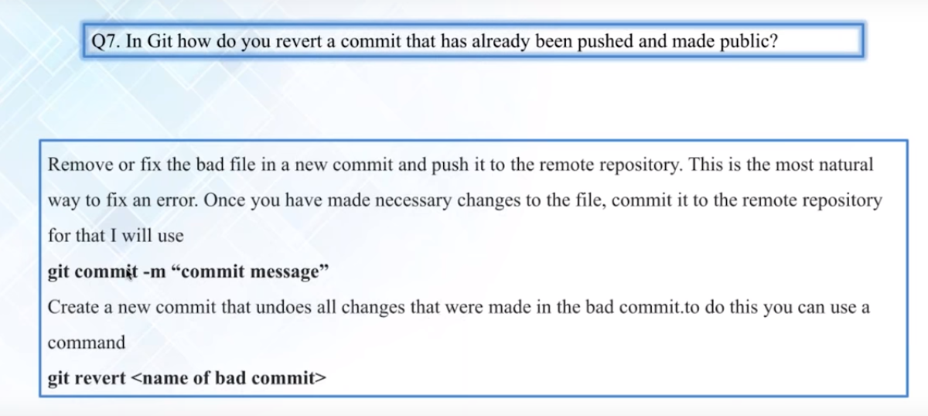

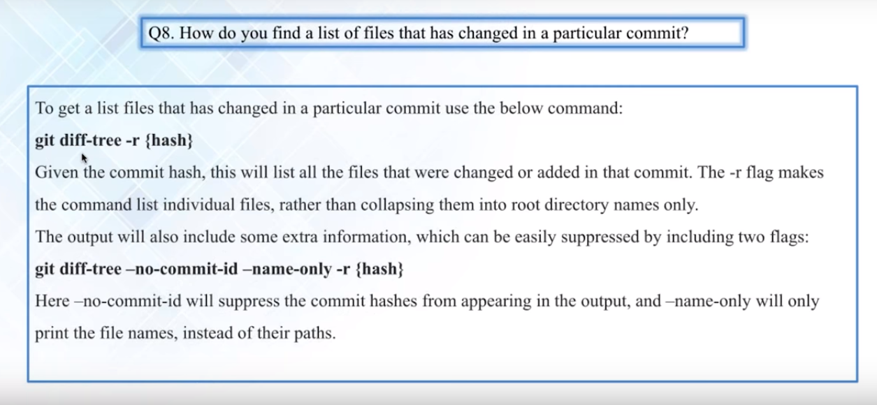

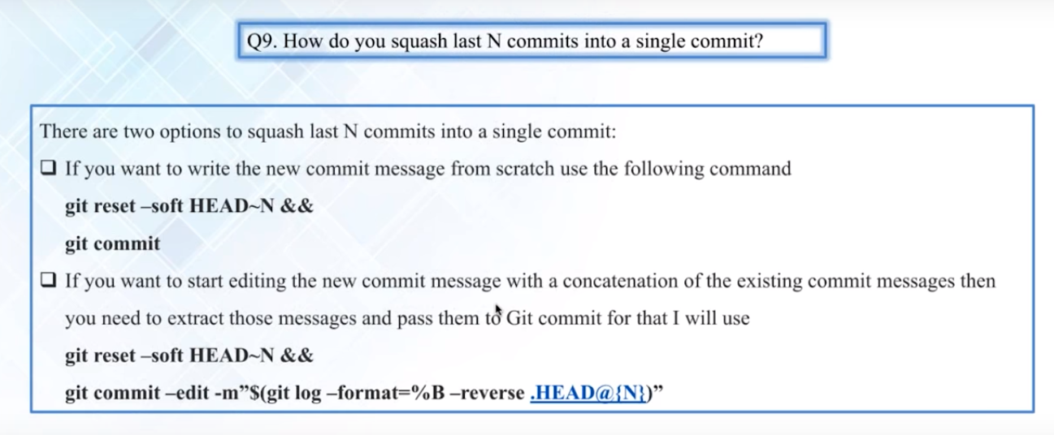

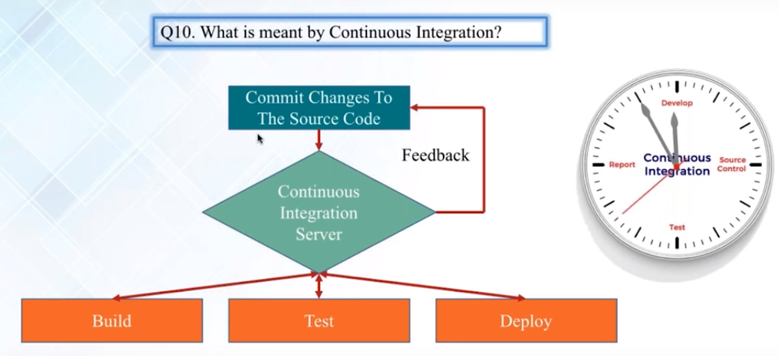

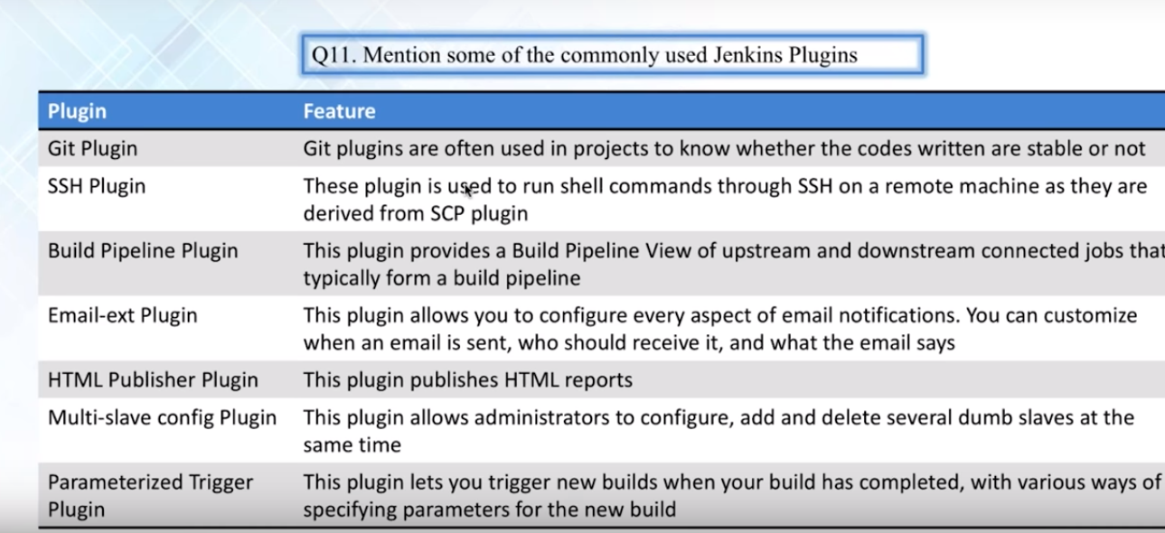

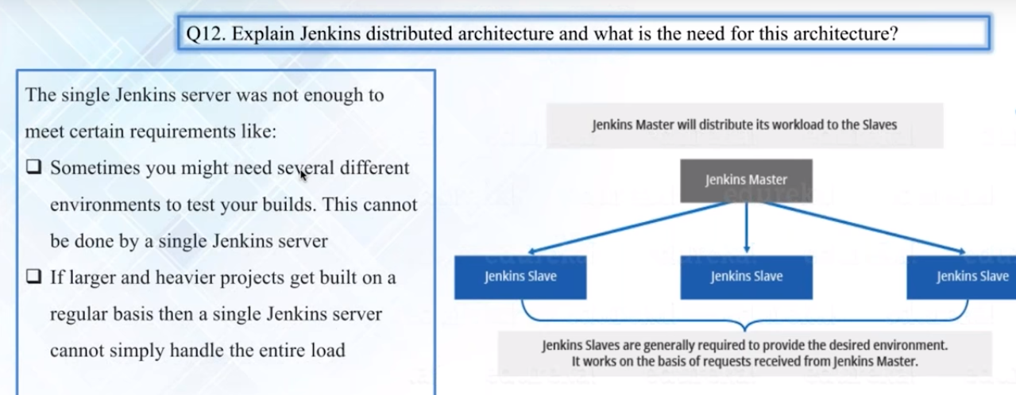

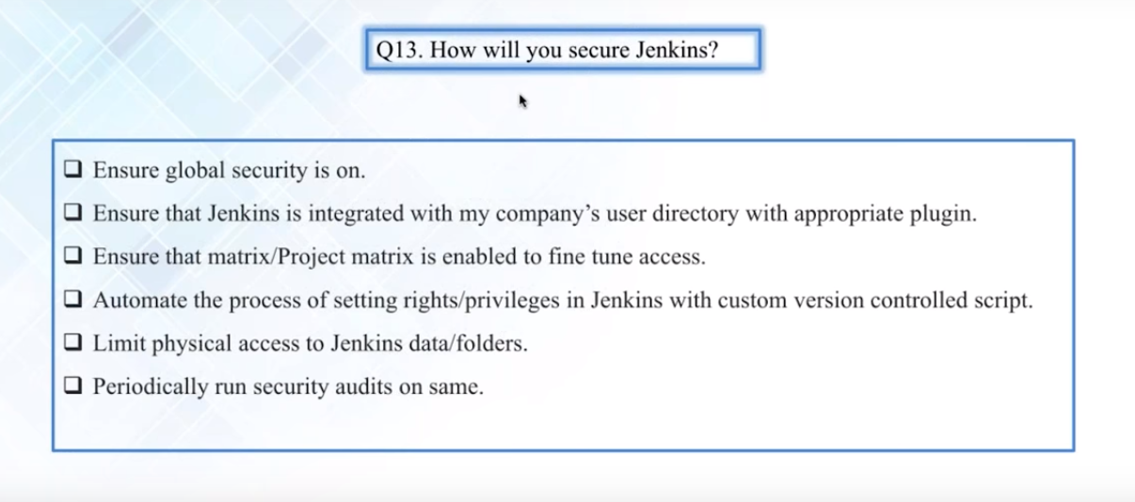

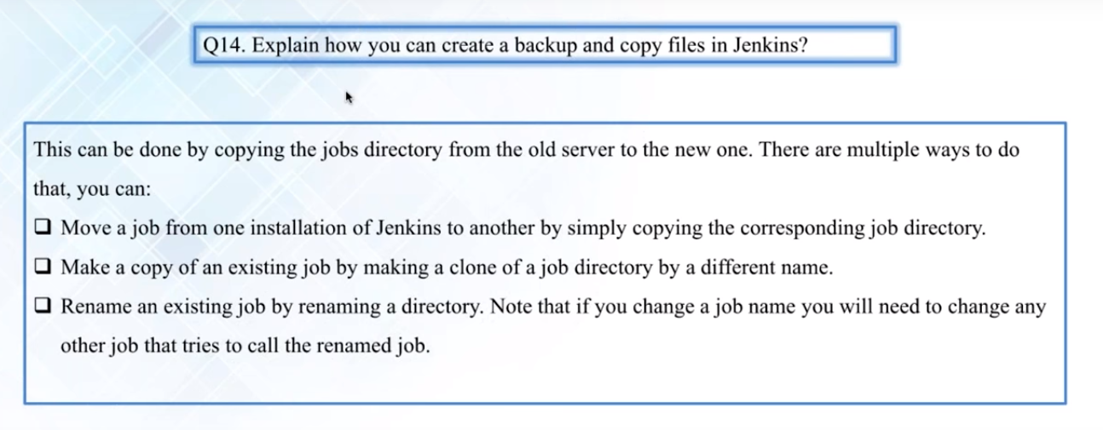

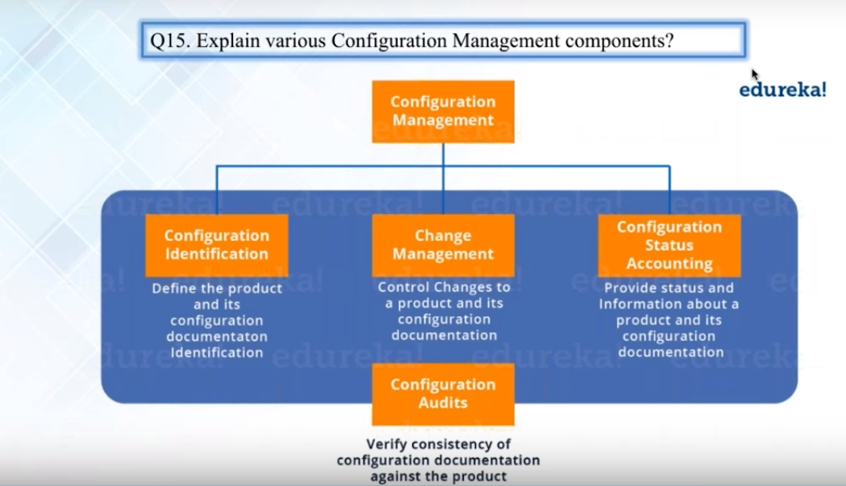

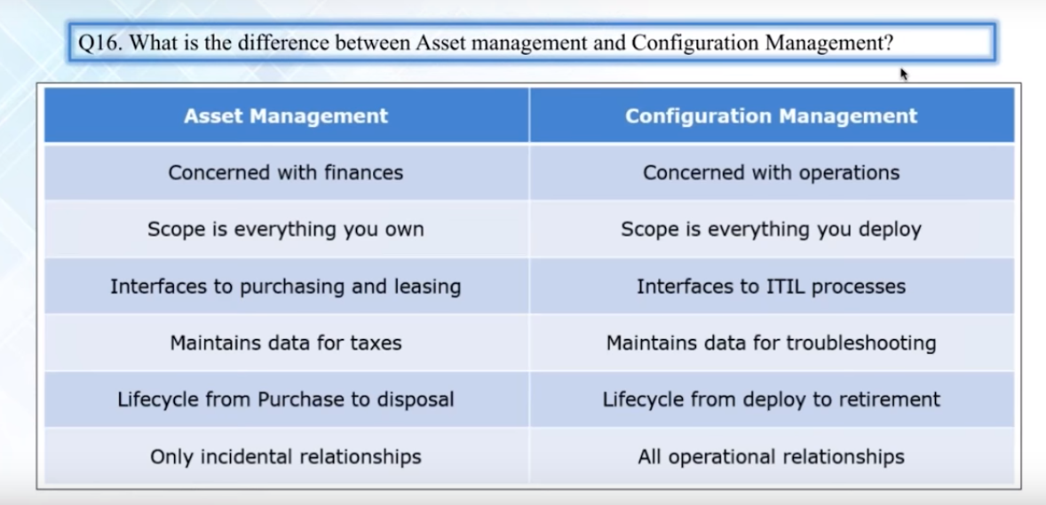

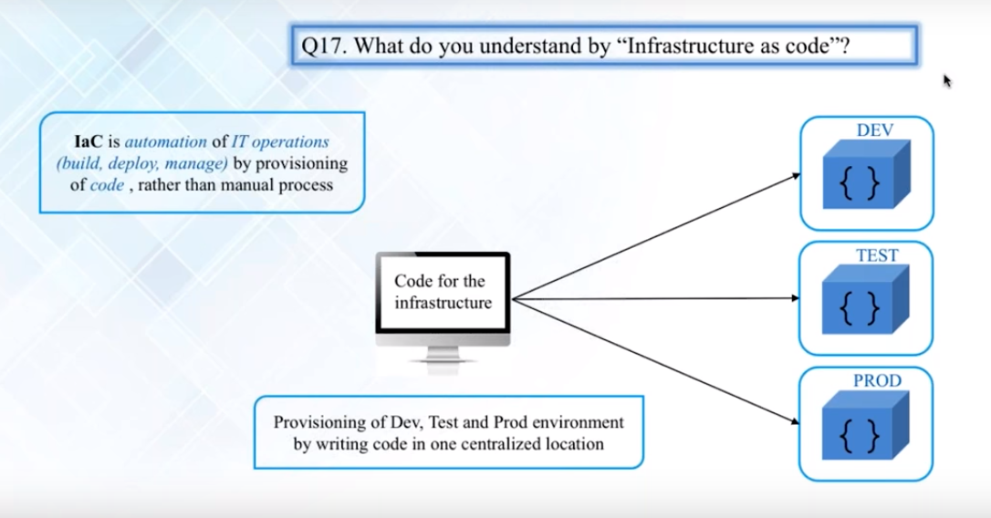

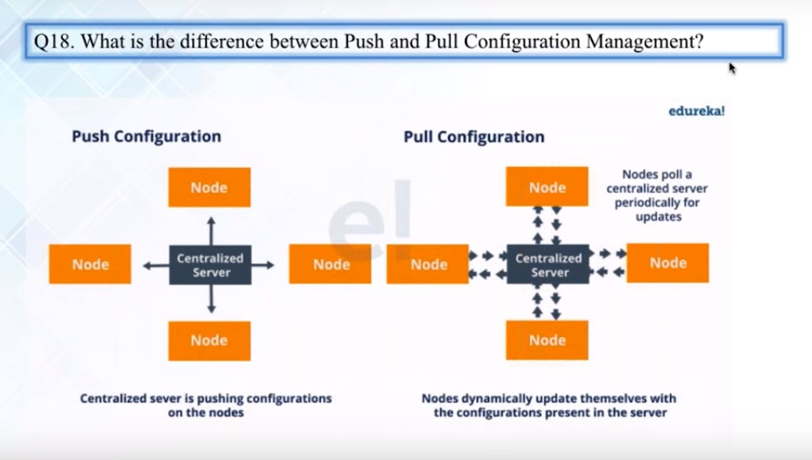

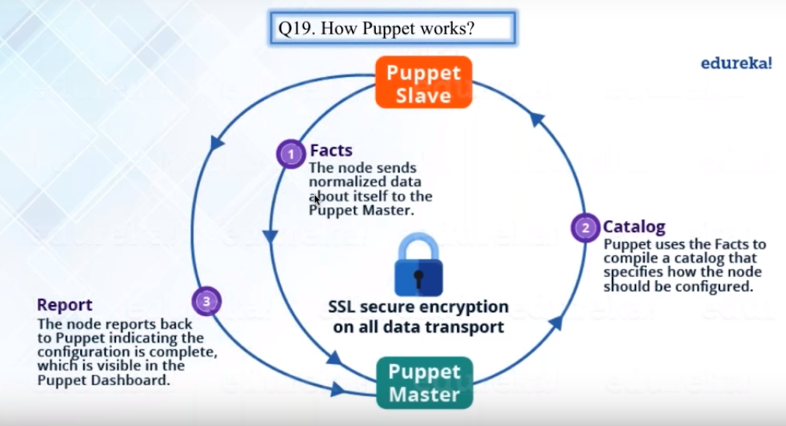



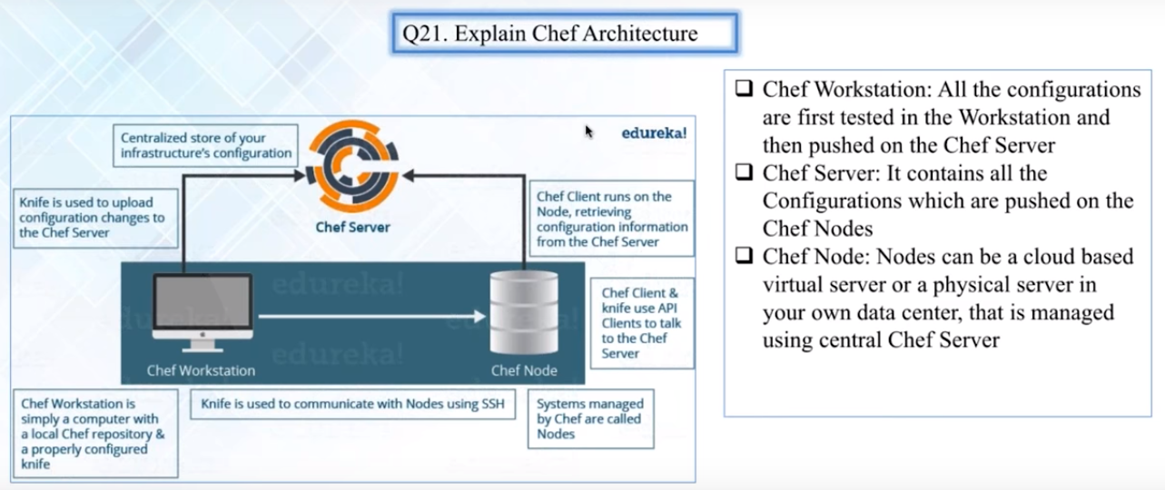

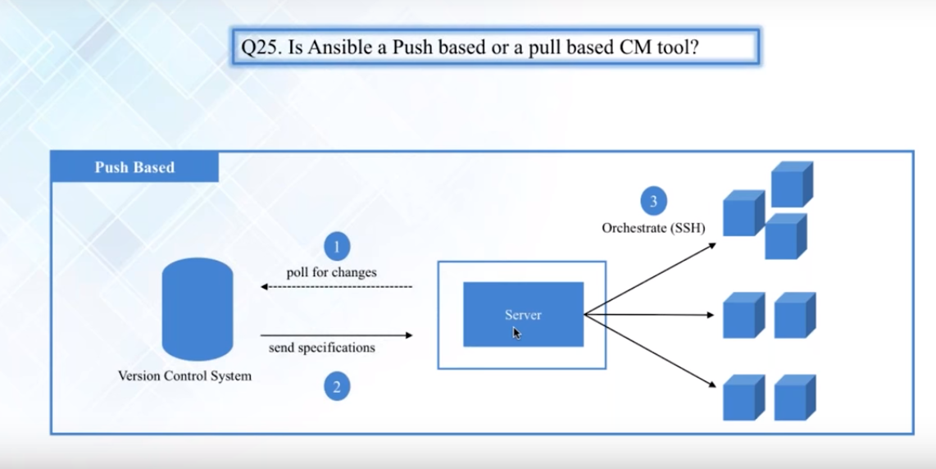

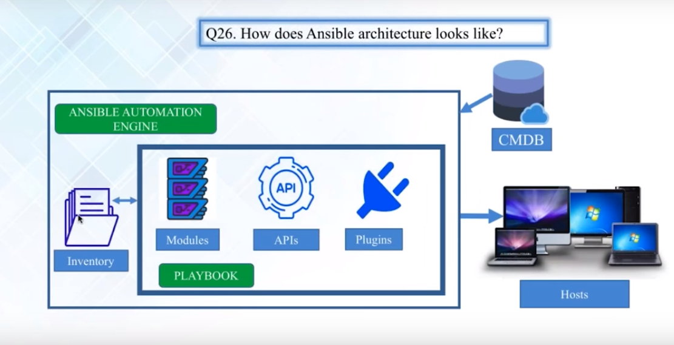

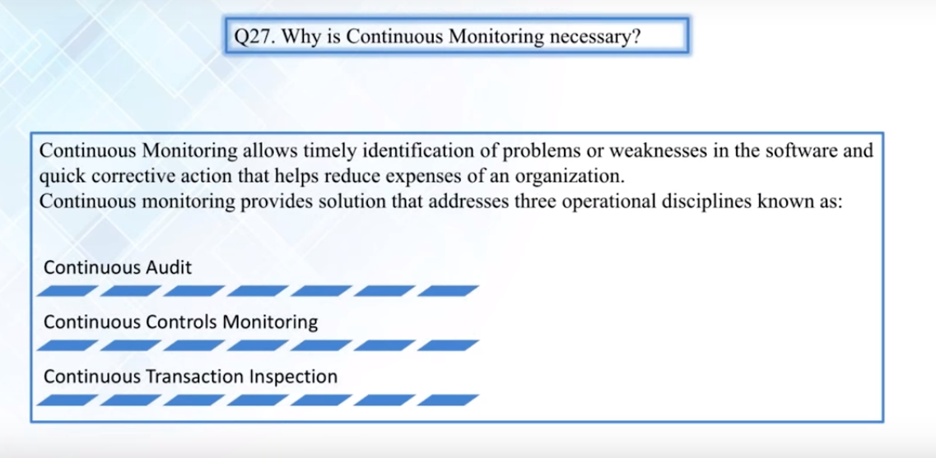

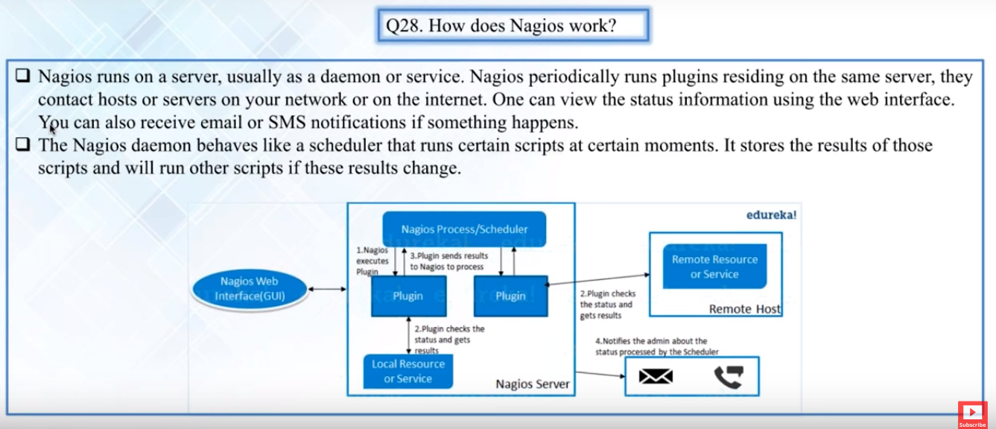

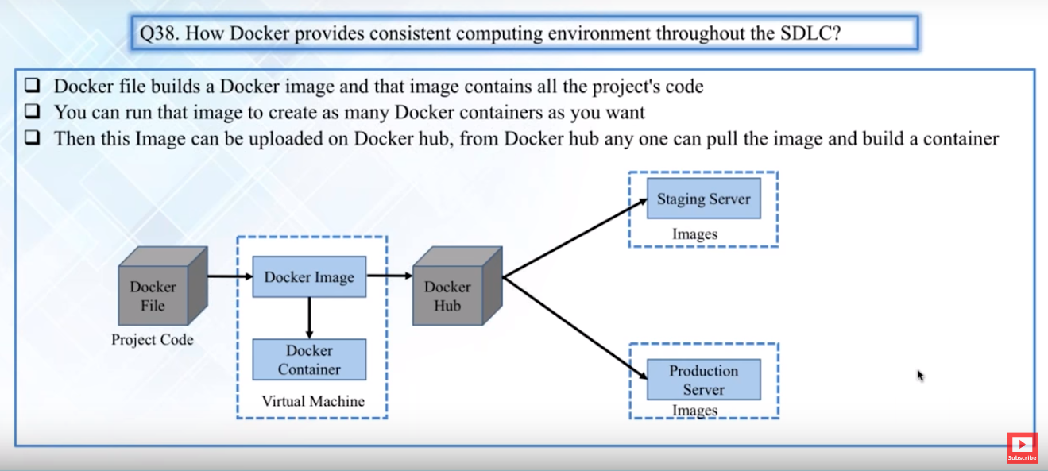

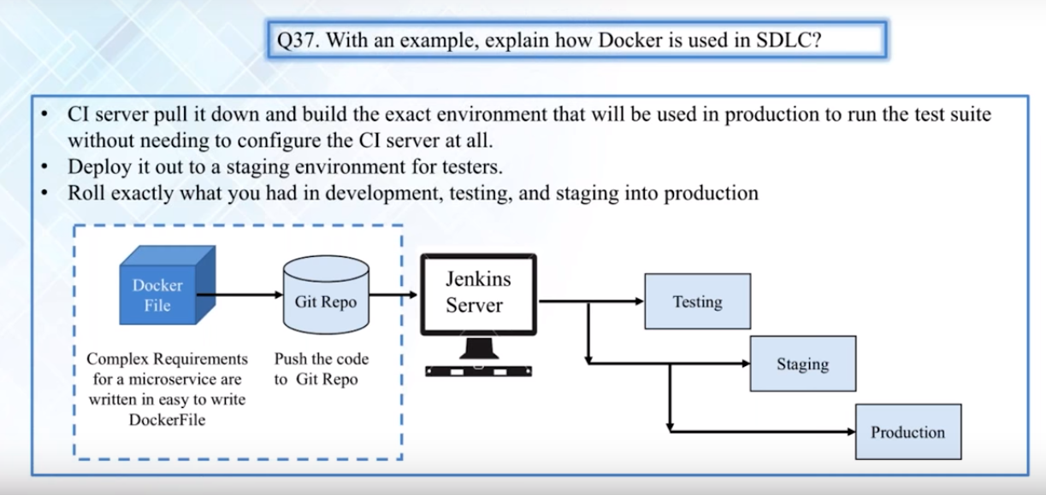

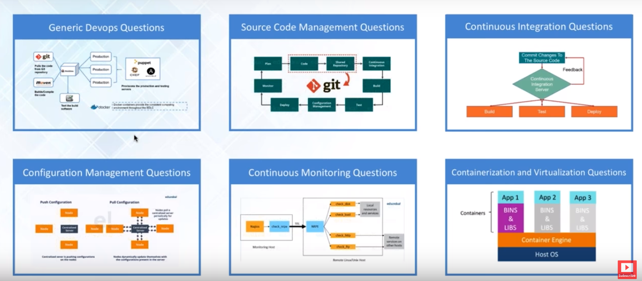

DevOps Basics

Devops in action-

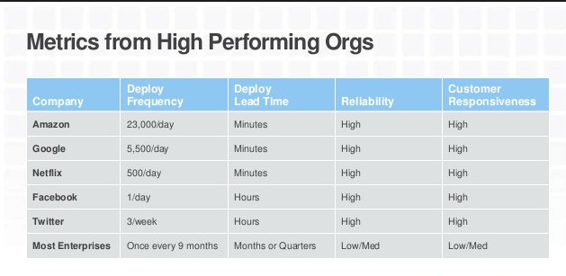

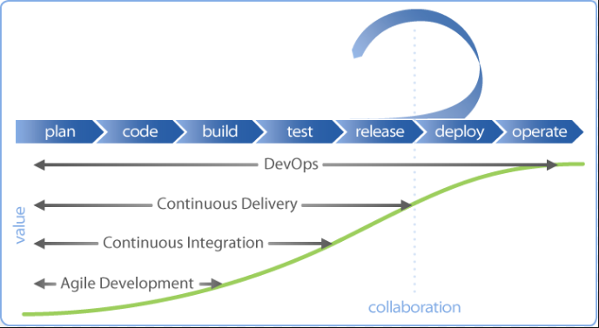

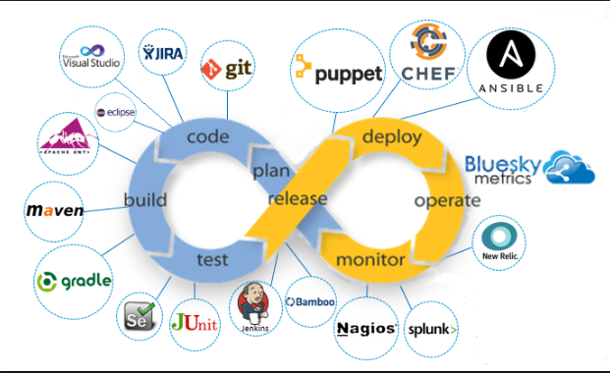

Core focus of agile is to braek the wall between business and development

Devops breaks the wall bet development and operation team

Devops Tools

